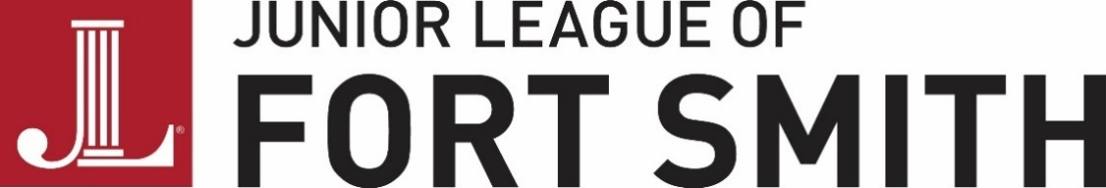
Marble Hall Facility Rental Agreement - EXHIBITC
COVID-19 ADDENDUM
In response to COVID-19, The Junior League of Fort Smith, Inc. (“Lessor”) is excited to welcome you (“Lessee”) to Marble Hall (“Facility”) while adhering to necessary restrictions and guidelines. We sincerely hope you enjoy your rental(“Event”) while encouraging Center for Disease Control (CDC) guidelines and adhering to all federal, state, and local government mandated procedures.
FOLLOWING CENTER FOR DISEASE CONTROL (CDC) GUIDELINES: The Lessee and employees, agents, vendors, and guests of Lessee should follow all guidelines set forth by the CDC:
- Frequent hand washing is encouraged
- Proper usage of face masks is encouraged
- Social distancing of six (6) feet or more is encouraged
- It is recommended that individuals 65 years of age or older should not attend in-person social events
- It is recommended that individuals with underlying health conditions who may be considered high-risk should not attend in-person social events
DENIAL OF FACILITY ACCESS:
- The Lesseewill not be granted access to the Facility if he/she/they have a confirmed active case of COVID-19 on or before the Event date.
- The Lessee will not be granted access to the Facility if he/she/they have had known exposure to someone with COVID-19 in the past fourteen (14) days.
- The Lesseewill not be granted access to the Facility if he/she/they have fever, cough, shortness of breath, sore throat, loss of taste or smell, or any other signs indicating he/she/they may have COVID-19.
The Lessee is not permitted, under any circumstances, to allow an attendee, vendor, agent, or guest onto the premises if any of the following occurs:
- The individual has a confirmed positive case of COVID-19
- The individual has been in contact with someone who has tested positive for COVID-19 within fourteen (14) days prior to the Event date
- The individual has a fever, cough, shortness of breath, sore throat, loss of taste or smell, or shows other signs indicating that he or she may have COVID-19
- The individual did not bring an adequate form of face covering
- The individual refuses to comply with Lessor procedures, Arkansas Department of Health restrictions, and/or CDC guidelines
THE FACILITY: The Lessor has taken necessary measures to protect the Lesseeand guests by implementing the following:
- The Facility will be cleaned and disinfected before and after all rentals
- Touchless soap dispensers have been made available for use
- Hand sanitizer has been made available for use
ELIGIBLE REFUNDS: The Lessor agrees to refund the rental fee, less any fees incurred by Lessor on behalf of Lessee, so long as the Lessee notifies Lessor of cancellation one (1) week prior to the Event date and so long as it is satisfactorily proven that late cancellation is due to COVID-19 constraints.
- The Lessor reserves the right to request proof that cancellation was in fact due to COVID-19 constraints. If satisfactorily proven, the Lessor agrees to refund the Lessee within fourteen (14) days of the previously scheduled Event date.
- The Lessor reserves the right to cancel the Event without warning in response to federal, state, or local government mandated closure. If this occurs, the Lessor agrees to refund the rental fee, less any fees already incurred by Lessor on behalf of Lessee.
- The Lessor reserves the right to cancel the Event without warning if it becomes known that an outbreak occurred inside the Facility immediately prior to the scheduled Event. The Lessor agrees to refund the rental fee, less any fees already incurred by Lessor on behalf of Lessee.
HOLD HARMLESS: The Lessee is responsible for his/her/their guests, employees,vendors, and agents and their observance of all rules and regulations specified by the Lessor, the Arkansas Department of Health, and the Center for Disease Control. Lessee agrees to hold Lessor, and theofficers, directors, and employees acting on behalf of Lessor, harmless in the event that Lessee or Lessee’s guests do contract COVID-19 at the Event.
Not abiding by the Facility rules could result in loss of some, or all, of the deposit, at the discretion of the Lessor.
No verbal agreements will be honored. Any addendum to the Agreement must be made in writing.
LESSEE:
I acknowledge the foregoing rules and agree to abide by and adhere to each listed rule. I also acknowledge that I am willingly entering into this agreement knowing the risk and I, acting as an agent on behalf of Lessee, will hold the Lessor harmless.
__________________________________
Individual or Organization (Lessee)

___________________________________
Signature of Lessee’s Representative

___________________________________
Printed Name of Lessee’s Representative

___________________________________
Date

